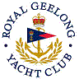 | Royal Geelong Yacht Club Inc.  Est 1859
Trophy Deed of Gift.

Trophy: | International Red Hand Trophy
Presented by: | Bellarine Marine (Jim Sim prop)
Date: | 1970
For: | Dragon Winter Aggregate.  Only 3 winter series for Dragons run.
Remarks / Revisions | 1990: Reallocated to Combined Handicap Winner of event so named  2005-2006: Reallocated to Div. III Aggregate Winner (2005-2006 => 2009-2010)
Click here for Dragon Winter Series Aggregate Winners
Click here for Div. I / II Winners (1990-2005)
Click here for Div. III Aggregate Winner

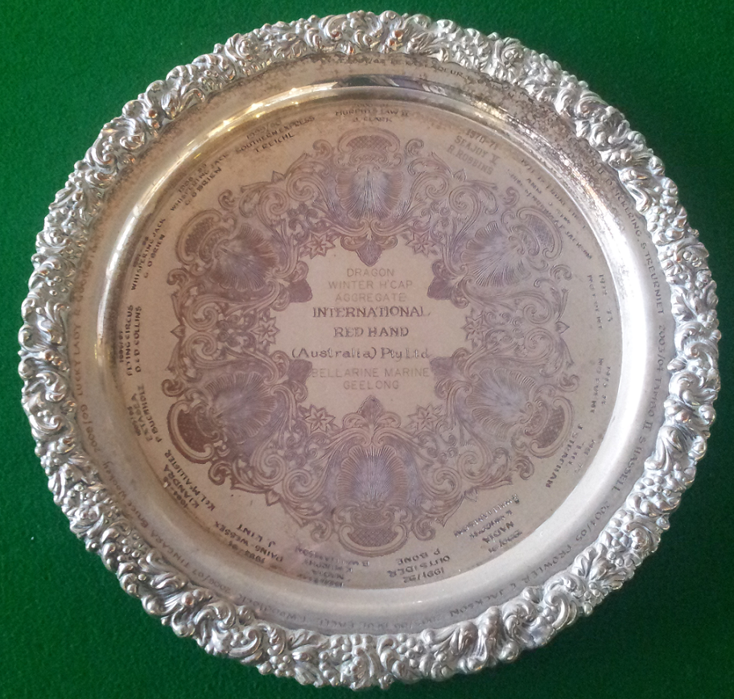

From 2010 on Div. III Aggregate transferred to Beta Tray

